**Restaurant Chain Productivity Portal**

**1. Project Overview**

* **Project Name: Restaurant Chain Productivity Portal**
* **Project Sponsor: Sukhjeet Jatana**
* **Business Owner: Sukhjeet Jatana**
* **Stakeholders: Sukhjeet Jatana**
* **Objective:**
* To develop a productivity portal streamlining restaurant operations, including payroll management, daily activity tracking, employee management, and business reporting.
* **Scope:**
  + The portal will manage payroll, track daily activities, and handle employee data. It will also generate detailed reports (sales, payroll, employee performance) and house an operations and marketing library.
* **Stakeholders:**
* **Direct Stakeholders**:
  + Owners
  + Supervisors
  + Admin
* **Indirect Stakeholders:**
  + Employees

**2. Business Goals & Objectives**

1. The login page would be accessible to the owner and supervisor.
2. The homepage with an overview of the company and Navigation bar would have ‘Activity,’ ‘Reports’, and ‘Operations & Marketing Library’ tabs.
3. Streamline payroll processing and ensure accurate, timely payments.
4. Track daily operational activities, including inventory and sales.
5. Provide real-time employee performance tracking and management.
6. Generate detailed reports for sales, payroll, employee performance, and operational activities.
7. Offer an ‘Operations & Marketing Library’ for best practices, guides, and promotional materials.

**3. Functional Requirements**

1. **Login Access:** The login page would be accessible via their user-id and password
   1. **Owner:** The owner can be the same for many restaurants.
   2. **Supervisor**
   3. **Admin:** He’ll have access to enter the restaurant’s name and location. Besides this, he’ll be able to add the Owner and Supervisor‘s names.
2. **Homepage and the Navigation bar:**
   1. **Homepage:** The homepage would have the details of that restaurant and the images if needed.
   2. **Navigation Bar:** The navigation bar would have three tabs
      1. **Activity tab**
      2. **Reports tab**
      3. **Operations and Marketing Library tab**
3. **Activity tab:**
   1. 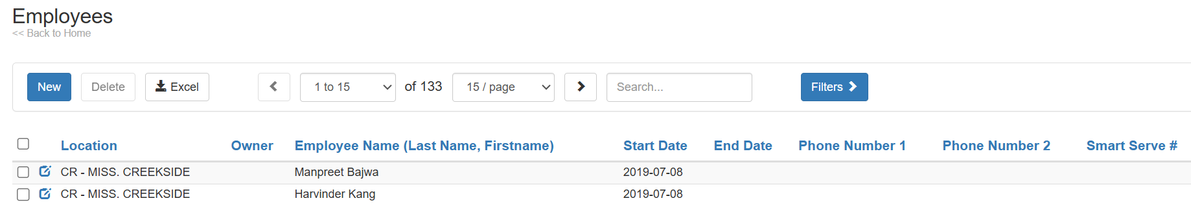**Employee Management Tab:**

Figure

1. Maintain employee profiles, including complete employee data records like Excel, with proper heads and the data below.
2. Add new employees:
   * + **Clicking on “New,” both the supervisor and owner would be able to add a new employee.**
     + **Boomerang employees would be handled with a new entry while keeping the past record.**
     + There are following tabs:
       1. **Employee Tab**: The following details will be taken from the above screen-shot ‘Figure 1’ & ‘Figure 2’

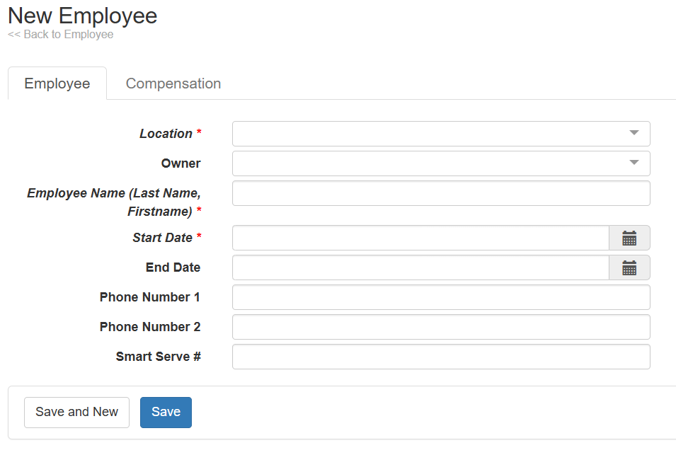

Figure

* + - * + “Location of the branch”
        + “Employee Name”
        + “Start Date”: With calendar access
        + “Phone Number”
        + “Smart Serve license”
      1. **Compensation Tab:**

Figure

These details would be auto-filled from the previous tab

* + - * + “Name”
        + 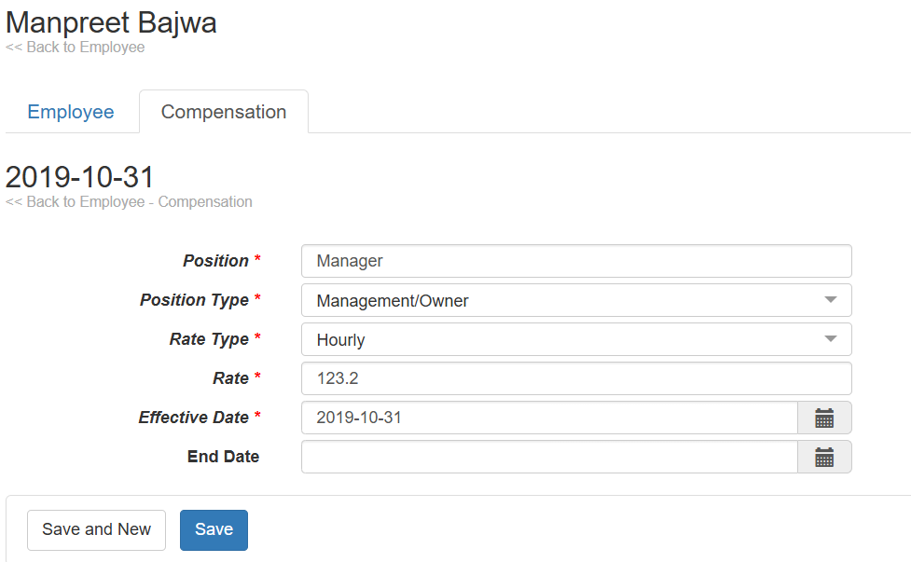“Effective Date”
      * The following details will be added from the above ‘figure 3’:
        + **Position Type**: The position types are like this

“Front of house”

“Back of House”

“Supervisor”

“Owner”

* + - * + **Rate Type**:

*“Hourly”*

*“Daily Salary”*

* + - * + **Rate**: The rate would get automatically added.

1. Search-Engine Functionality: Typing in just the starting few initials would display those records.
2. Delete records: Deleting after the selection of a few or a bunch of searched records would be possible.
3. Edit access: **Both the supervisor and owner would have edit access.**
4. Download Excel: Employee data will be downloaded after clicking on the download button.
   1. **Employee Payroll:**
      1. 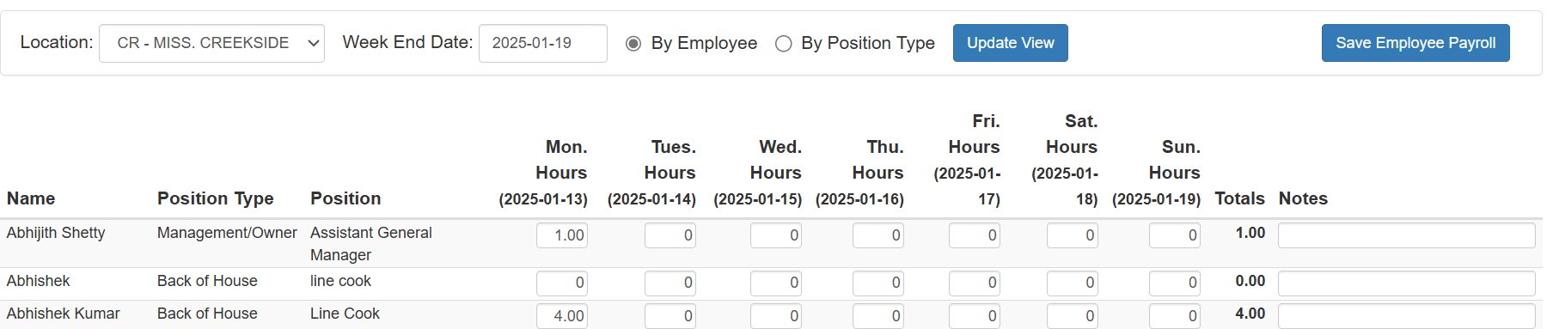Supervisors need to enter the week’s end date accordingly. It’ll show that week’s chart.

Figure

* + - * The table would consist of the following as ‘Figure 4’:
        1. **Position type**
        2. **Name**
        3. **Position**
        4. **Working hours/ day columns**
        5. **Total hours/ day(s) work**
        6. **Notes columns**
    1. There’ll be the option to enter ‘1’ if the salary type is ‘Daily Salary’ and ‘hours’ if the type is ‘hourly salary.’
    2. Entering the week-end date is mandatory to get a specific week’s chart.
    3. **Edit access** will be **available with** the **supervisor** **till next Monday at 2 pm**.
    4. The owner can edit the attendance data anytime.
    5. The chart would be visible by:
       - Position
       - Name
  1. **Daily Activity Tracking:**

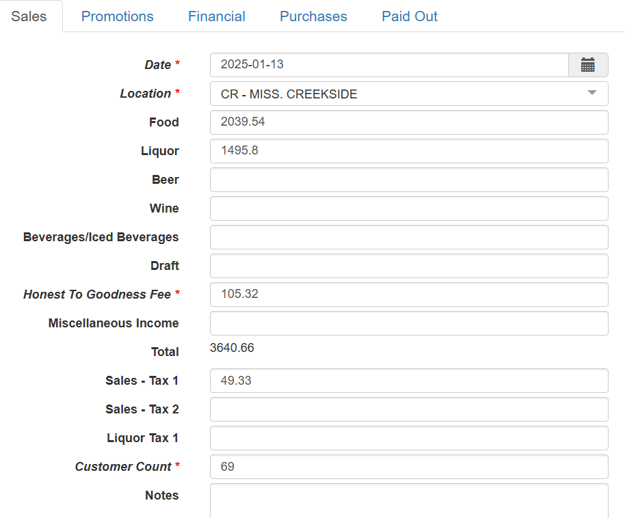Daily Activity would include the following tabs:

Figure

1. **Sales**: Following details would be there as in ‘Figure 5’:
   1. **Current Date**: It’ll get added automatically. (There should be one calendar at the end of the cell)
   2. **Location**: It’s also automatic.
   3. **Food:** *Integration needs to be with Clover*
   4. **Liquor:** *Integration needs to be with Clover*
   5. **Total**
   6. 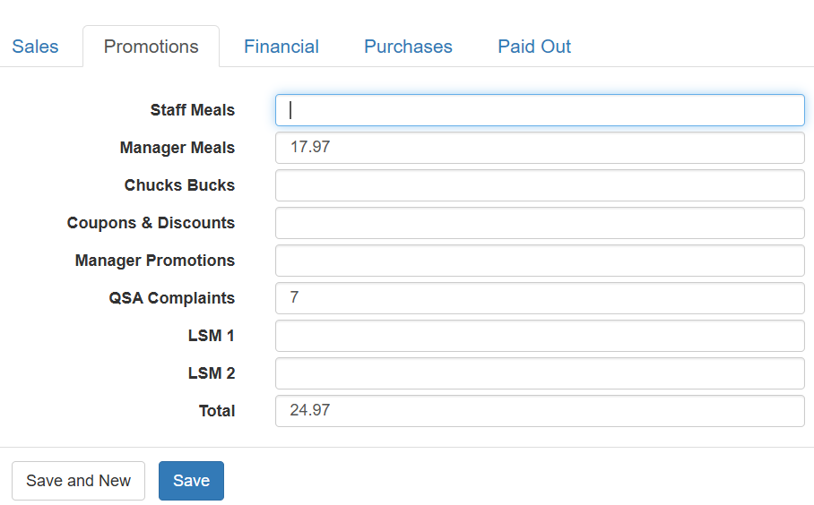**Sales Tax 1**

Figure

1. **Promotion: The tab would include the following details as in ‘Fig. 6’**
   1. **Staff’s meal**
   2. **Coupons & Complaints**
   3. **Manager Promotions**:
   4. **QSA Complaints:** Total free food given on a daily basis
   5. **Total**: The total amount will be shown here

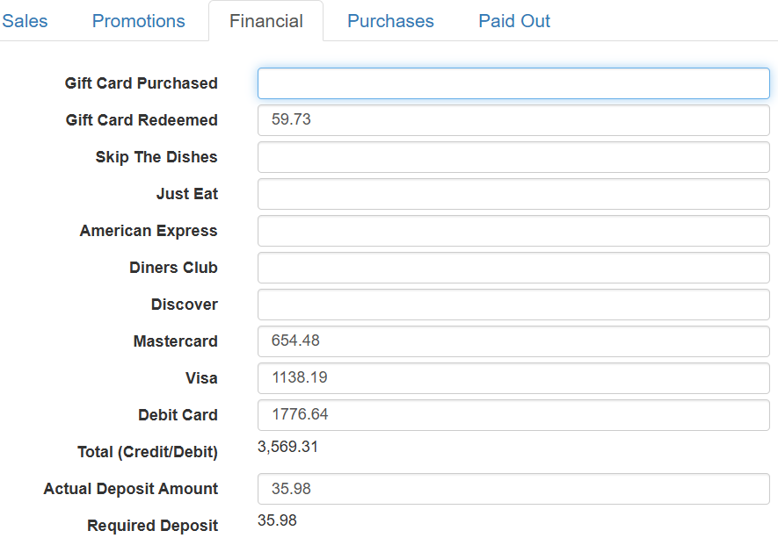(Here, it’s confusing as some fields need to be filled manually while others get auto-filled via the PSO Clover report. Please, specify this part that which fields need to be manual.)

Figure

1. **Financial: All** **these rows would be filled by POS as shown in ‘Fig. 7’**
   1. Gift Card Purchased
   2. Gift Card Redeemed
   3. Skip the Dishes
   4. Just Eat
   5. American Express
   6. Diners Club
   7. Discover
   8. Mastercard
   9. Visa
   10. Debit Card
   11. Total
   12. 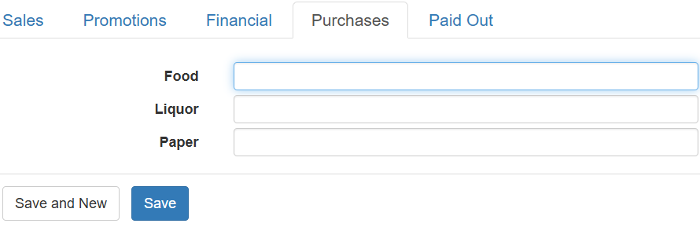**Cash Deposit Amount**: The system needs to calculate this row.

Figure

1. **Purchases:** This is the amount purchased; the following are the rows to be filled as in ‘Fig. 8’
   1. **Food**
   2. **Liquor**
   3. **Paper**

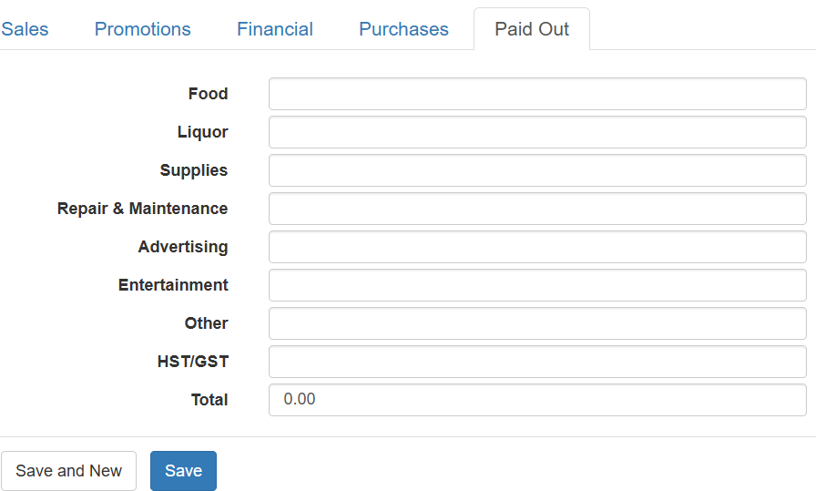(These fields need to be filled manually or via/ POS)

Figure

1. **Paid-Out: The following are the rows as in ‘Fig. 9’**
   1. **Food**
   2. **Liquor**
   3. **Supplies**
   4. **Repair & Maintenance**
   5. **Advertising**
   6. **Entertainment**
   7. **Other**
   8. **HST/GST**
   9. **Total**

(How these rows will get filled and what it is about)

1. **Reports & Analytics:**
2. **Payroll Reports:**
   1. Generate detailed **payroll report** of employee by **daily** (Is there some requirement of Daily pay-roll report?)**, weekly, and month**.
   2. Need to **enter below details to get a pdf**:
      1. **Week end date**
      2. **Location**
      3. **Report format**
   3. Pdf would consist:
      1. **Employee’s name**
      2. **Position**
      3. **Employee’s rate (Constant rate on hourly basis), Hours, and Total**
      4. **Week Total hours and total amount**
3. **Sales Reports:**
   * + - 1. Generatedaily,weekly, monthly sales performance reports.
         2. Need to **enter below details to get a pdf**:

**Week end date**

**Location**

**Report format**

* + - * 1. The report would consist following rows:

**Company’s logo: CHUCK’s ROADHOUSE**

**Day of Week**

**Date**

**Cash Deposits**

* Skip the Dishes
* Just Eat
* Mastercard
* 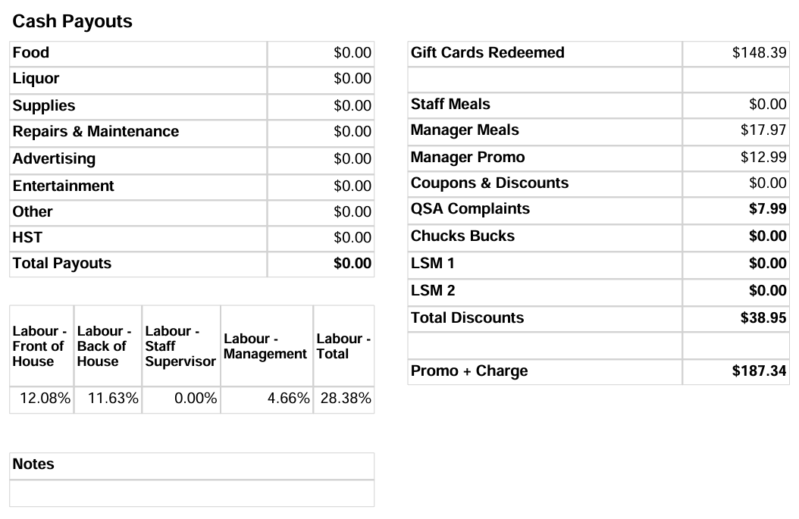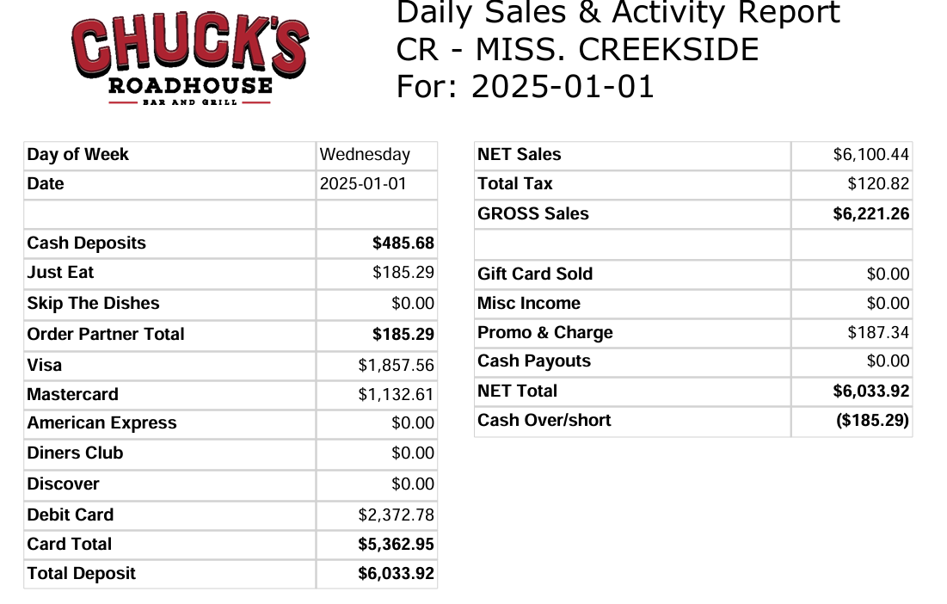American Express

Figure

* Dinners Club
* Discover
* Debit Card

**Card Total**

**Total Deposit**

**Labour Cost**

* Labour Cost of Front of House
* Labour Cost of Back of House
* Labour Cost of staff/ Supervisor
* Total Labour Cost

1. **Cash Payouts**
   * + - * Food
         * Liquor
         * Supplies
         * Repair & Maintenance
         * Advertising
         * Entertainment
         * Other
         * HST/GST
         * Total

**Net Sales**

**Total Tax**

**Gross Sales**

* Gift Card Sold
* Misc Expenses
* Promo & Charge
* Cash Payouts
* **NET TOTAL**
* **Cash Over/short**
* Gift Card Redeemed
* Staff Meals
* Manager Meals
* Manager Promo
* Coupons & Discounts
* QSA Complaints
* LSM1
* **Total Discounts**

**Promo + Charges**

1. **Flash Report:**
2. **Summary Report**:

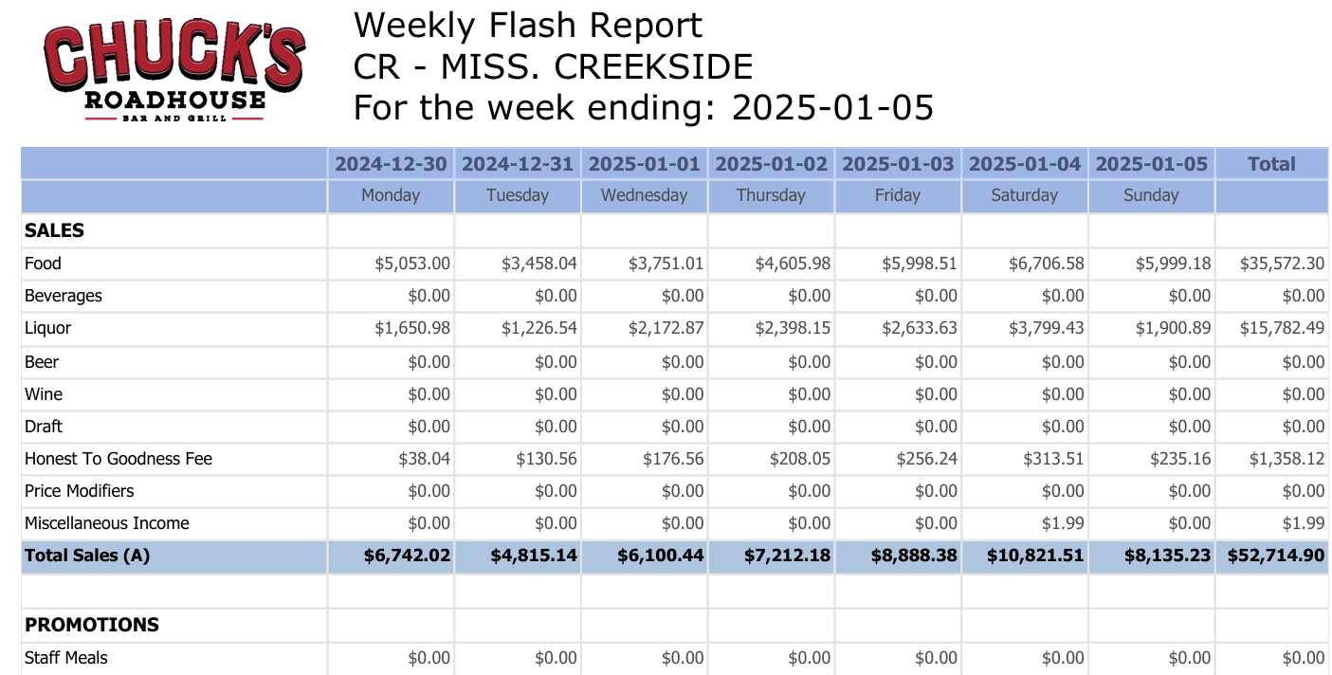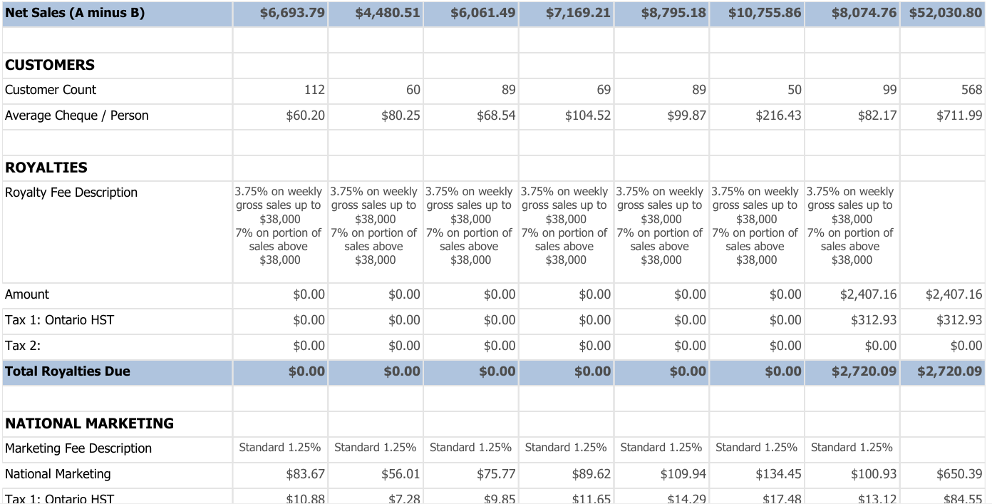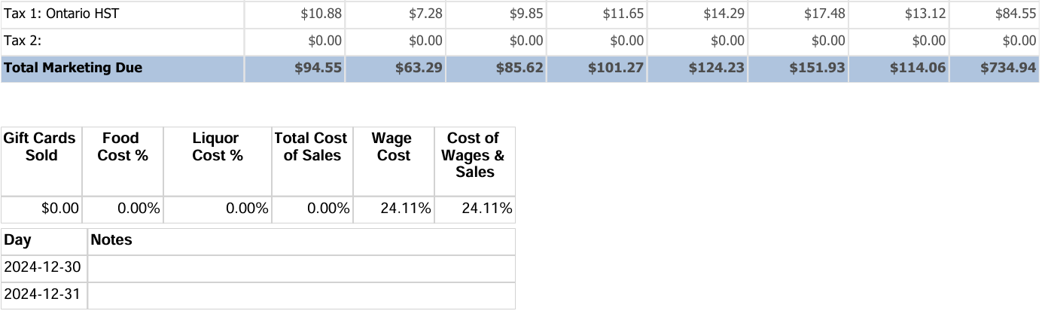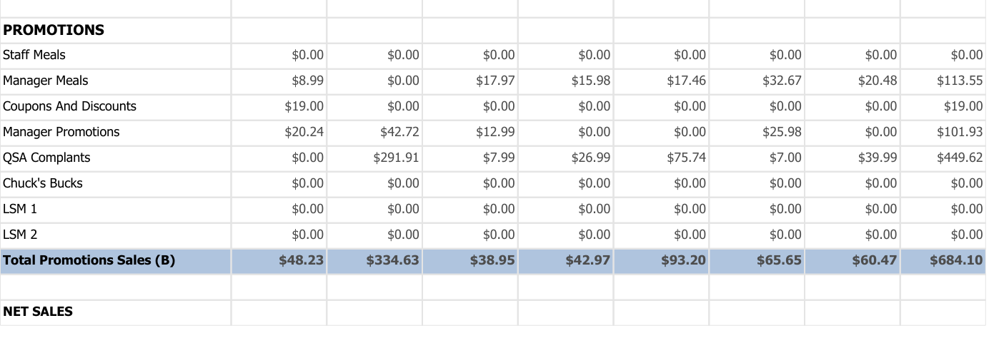There needs to be a **pdf view option available besides downloading the pdfs.**

(Clarify what reports are needed. What about Flash report, Promo Report, Wage Cost Report, etc.)

1. **Operations & Marketing Library:**
   1. A digital repository for operations manuals, SOPs, and marketing materials.
   2. Medium for creating and sharing documents.

**4. Non-Functional Requirements**

* **Usability:**
  + **User-friendly interface for easy navigation, with accessibility features.**
* **Performance:**
  + **The portal should load quickly, with real-time data updates for operational and payroll activities.**
* **Security:**
  + **Data encryption, secure login, and user role management.**
* **Availability:**
  + **24/7 availability with minimal downtime.**
* **Scalability:**
  + **Support the growth of the restaurant chain, including features to add additional locations and users.**

**5. Technical Requirements**

* **Platform:**
  + *Web-based application with mobile compatibility.*
* **Integration:**
  + **Integration with existing point-of-sale (POS) systems (CLOVER).**
* **Database:**
  + Would use **‘MySQL’** to create Employee/ owner tables, sales table, etc.
* **Technology Stack:**
  + Frontend (HTML and CSS)
  + Backend (Python and Flask)
  + Cloud hosting (Hostinger)

**6. User Interface (UI) Design**

* **UI Mock-ups:**
  + Creation of dashboard, reports, and library access.
* **Branding:**
  + Consistent with restaurant branding guidelines **(logos, colours, fonts, images).**

**7. Data & Reporting**

* **Data Collection:**
  + Data to be collected from POS and rest it needs to be added manually by the Supervisor/ Owner.
* **Report Generation:**
  + Detailed, customizable reports for sales, payroll, and Summary.

**8. Implementation & Deployment**

* **Deployment Timeline:**
  + **High-level timeline for development, testing, and deployment.**
* **Training Requirements:**
  + **Employee and manager training for payroll, daily activity tracking, and report generation.**
* **Support & Maintenance:**
  + **Ongoing support for issues, feature requests, and regular system updates.**

**9. Success Criteria**

* **Reduction in payroll processing time and errors.**
* **Improved operational efficiency and real-time tracking.**
* **Positive feedback from staff on usability and efficiency.**
* **Organised and smooth web-portal.**
* **Increased sales and productivity metrics.**

**10. Risks**

* **Risks:**
  + **Resistance to change from employees or managers.**
  + **Integration issues with existing systems (POS).**

**11. Approval & Sign-off**

* **Approval Signatures:**
  + **Space for key stakeholders to approve and sign off on the business requirements.**